Markers[0] = Marker 5 (used for HeadRigidBody)

Markers[1] = Marker 6 (used for HeadRigidBody)

Markers[2] = Marker 10 (???)

Markers[3] = Marker 8 = MouthOpeningMarker1

Markers[4] = Marker 9 = MouthOpeningMarker2

Markers[5] = Marker 7 (used for HeadRigidBody)

Markers[6] = Marker 15 = MouthStretchingMarker1 = MouthProtrusionMarker1

Markers[7] = Marker 16 = MouthStretchingMarker2 = MouthProtrusionMarker2

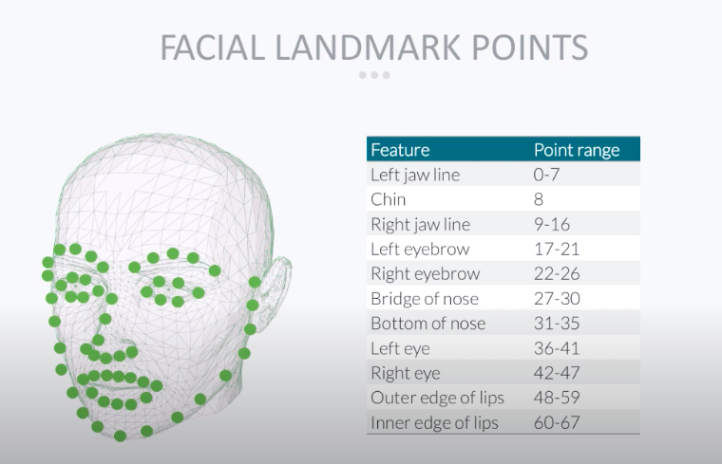

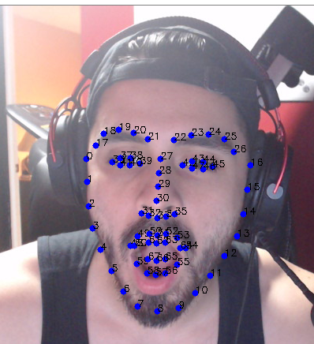

Marker 7

Marker 16

Marker 15

Marker 9

Marker 8

Marker 10

Marker 5

Marker 6